Program 2: Battle Game

Review Topics:
- Input/Output  - Variables  - Math | - If Statements  - Loops  - Functions

About:
You will implement a turn-based text game.
Each round, the screen will display the player and the enemy's HP (hit points), then display a menu for turn options: Attack or Heal.
We will generate random values for attack damage and healing value, as well as for the enemy behavior. Once either the player or enemy reach 0 HP, the game will end.

Sample Output
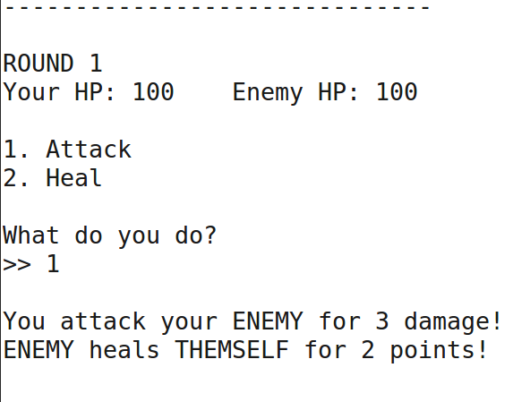

Program Spec:

Functions to write:

DrawSeparator
Return type: void
Parameters: length (int)
Draw a horizontal bar, with the length of the parameter length. Use a for loop and cout.

DisplayMenu
Return type: void
Parameters: round (int), playerHP (int), enemyHP (int)
Display a separator (DrawSeparator), display the current round, the player's HP, the enemy's HP,
and two options: 1 for Attack and 2 for Heal.

GetChoice
Return type: int
Parameters: minimum (int), maximum (int)
This function prompts the user for input and validates that the input received is between the
minimum and maximum values.
This function returns the validated user input.

GetAttack
Return type: int
Parameters: none
This function generates and returns a random number between 0 and 10.

GetHealing
Return type: int
Parameters: none
This function generates and returns a random number between 0 and 7.

Random Numbers
Make sure to #include <stdlib.h> library to be able to use random numbers. The rand() function allows you to generate a number, but you need to use the modulus operator % to restrict the random number size. Example:
Generate a number between 0 and 5:  int random = rand() % 5; | Generate a random number between 2 and 7:  int random = rand() % 5 + 2;

Main Program
In main() at the beginning of your program, declare the following variables:
- playerHP (int), initialize to 100
- enemyHP (int), initialize to 100
- round (int), initialize to 1
Create a while loop that will continue running the game until either the playerHP is 0 or the enemyHP is 0. (while both are greater than 0, keep running the game.)

Inside the Game Loop:
- Display the main menu via the DisplayMenu function
- Get the player's choice via the GetChoice function
- Handle the player's turn:
  - If the user entered 1 then:
    - Get a damage amount via the GetAttack function
    - Display a message about damage done to the enemy
    - Subtract the generated damage amount from the enemyHP.
  - Otherwise if the user entered 2 then:
    - Get a heal amount via the GetHealing function
    - Display a message about how much you're healing for
    - Add the heal amount to the playerHP.
- Handle the enemy's turn:
  - Create a variable called enemyChoice. Assign it a random value between 0 and 2.
  - If enemyChoice is 0:
    - Get a heal amount via the GetHealing function
    - Display a message about how much you're healing for
    - Add the heal amount to the enemyHP.
  - if enemyChoice is 1:
    - Get a damage amount via the GetAttack function
    - Display a message about damage done to the enemy
    - Subtract the generated damage amount from the playerHP.
- Increment the round variable just before the end of the while loop.

After the Game Loop:
Once the game has exited the while loop, check to see whose HP is less than or equal to 0. Display either “You win!” or “You lose!” based on whether the player won or the enemy won.
Then the game exits (it hits the end – return 0;)

Step-by-Step (Optional):
Use this guide if you're not sure how to begin.

Iteration 1
Create variables for the playerHP and enemyHP. Create a while loop that continues repeating, so long as playerHP is greater than 0 and enemyHP is also greater than 0.
Inside, don't bother with user input yet – subtract some value from enemyHP and playerHP.
Implement the check to see who wins after the loop is done. (whose HP is 0?)
Make sure that the game eventually ends.

Iteration 2
Implement the GetAttack and GetHealing functions.
Update the program so that the amounts being removed from enemyHP and playerHP is random.

Iteration 3
Add a menu within the while loop, asking the user if they want to 1. Attack, or 2. Heal.
Get the user's input.
If the player chooses attack, use the GetAttack function to subtract some amount of damage from the enemy.
If the player chooses heal, use the GetHealing function to add some amount of health to the player.

Iteration 4
Add another random value within the game loop, after the player's attack or heal turn. Set the random number to between 0 and 2. (so, either 0 or 1).
If the random number is 0, have the enemy attack the player.
If the random number is 1, have the enemy heal themself.

Iteration 5
Implement the GetChoice function – move your player input code into this function and return whatever value they input.

Iteration 6
Implement the DisplayMenu function – move your number menu code into this function.

Extra Credit
You can earn up to an extra 5% for additional features. Some suggested features to add to the game:
- Have a “defense” option, which lessens the amount of total damage that the player or enemy can receive. Both player and enemy should have the ability to defend.
- Have the player and enemy choose a weapon at the beginning, which determines their maximum damage amount.
- Have the player and enemy choose a food item at the beginning, which determines their maximum healing amount.

